**Interview script on one of the staff of Red Cross Pasay**   
  
Q: What is the step by step process on how people can avail of blood from your organization? For example if I were to search for blood, what are the steps I need to do?  
A: First step is you need or a pt need to secure blood request from the hospital/doctor for you to know what type of blood, component and number of units you’ll be needing. Second step is call any prc offices and make reservation if they have the available blood. Last step is go to the prc office and pay the processing fee to claim the blood you reserved.  
  
Q: What are the possible conflicts people encounter when searching or availing for blood? How are these conflicts addressed?   
A: Blood type availability is not guaranteed. It’s possible that stocks for certain blood type is unavailable. People will have to wait for stocks or they have to avail the blood type at a different Red Cross facility where stocks is available.

Q: How does Red Cross cope its stock in blood to the demands?  
A: To meet the increasing demand for blood and augment the national blood requirement, we conduct education and recruitment sessions to encourage regular voluntary blood donations from communities, different companies, organizations, colleges and universities nationwide. With different PRC blood service facilities strategically located in the entire country, the PRC collects blood from voluntary, non-remunerated blood donors with their donations accounting to almost 50% share of the nation’s blood supply.  
  
Q: How is blood stored and issued?

A: Once blood is suitable for transfusion, blood is stored in a temperature controlled blood bank refrigerator. Clients or patients needing blood for transfusion may request from any PRC blood facilities upon presentation of blood request form issued by the hospital or physician.

Q: How much will the blood cost? Is there any fees that needs to be paid?  
 A: We follow strictly the Department of Health standard. The financial requirements to ensure safe, quality and adequate supply of blood and blood products are relatively high, thus corresponding fees are authorized by the DOH. The PRC blood processing fees are in conformance with DOH Administrative Order No. 181 series of 2002 and per unit are: P1,500 for whole blood, P1,100 for packed red cells, and P700 for the rest of component blood products such as platelets, frozen plasma, cryoprecipitate and cryosupernate.  
  
Q: Does red cross own any app or website that addresses blood donors or blood recipients?   
A: We still don’t have any application. We have our own website, redcross.org.ph.

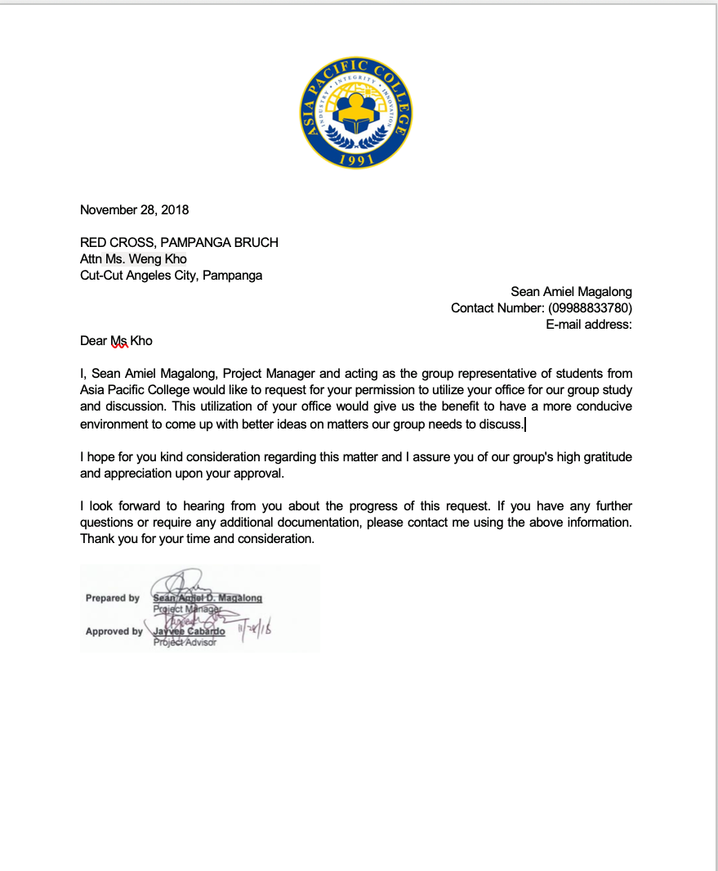



**SCHOOL OF COMPUTING AND INFORMATION TECHNOLOGIES**

# Applied Project 2 (CSPROJ2)

**Blood Findr**

CAGUIAT, LORD LAMBERSTON

2016-1000511

GLORIA, ENRICO

2016-200013

MAGALONG, SEAN AMIEL D.

2013-100091

NATO, VINCE MICKELL

2015-100372

**Project Title**

**Blood Findr**



**Table of Contents**

**Narrative**

Introduction1

Problem Statement1-2

Solution2-3

Project Context3-4

Purpose and Description4

Objectives4

Technical Background5

Target Audience5

Scope and Limitations5

SWOT Analysis6

Gap Analysis7

Review of Related Literature/Systems7-8

References8

**Diagrams**

Event Table9

Use Case Diagram10

Use Case Full Description11-14

Object Diagram15

Data Flow Diagram16

Context Flow Diagram17

Activity Diagram18-19

Class Diagram20

Entity Relationship Diagram21

Data Dictionary22

Sequence Diagram23

State Machine Diagram24

Timing Diagram25

Communication Diagram26

Component Diagram27

Deployment Diagram28

Package Diagram29

Use Case Package Diagram30

Composite Structure Diagram31

**Graphical User Interface**

Home32

Search33

Log In34

Sign Up35

Result Page36

Reservation Page37

Amount Due38

Conclusions and Recommendation39

**Project Professor**

|  |  |  |
| --- | --- | --- |
| **Name** | **Position** | **Email** |
| Mr. Manuel Sebastian Sanchez | Professor | manuels@apc.edu.ph |

**Project Team Members**

|  |  |  |
| --- | --- | --- |
| **Name** | **Position** | **Email** |
| Enrico Gloria | Project Manager | sdmagalong@apc.edu.ph |
| Vince Nato | Project Researcher | venato@apc.edu.ph |
| Sean Magalong | Project Analyst | ejgloria@apc.edu.ph |
| Lord Caguiat | Project Programmer | lcaguiat@student.apc.edu.ph |

**Project Adviser**

|  |  |
| --- | --- |
| **Name** | **Email** |
| Mr. Jayvee Cabardo | jvcabardo@apc.edu.ph |

**Project Consultant**

|  |  |
| --- | --- |
| **Name** | **Email** |
| Ms. Maricel Naviamos | shengnaviamos@gmail.com |

**Introduction**

Red Cross handles a blood bank and cater to clients in reserving any type of blood. Meanwhile, reservation of blood for various blood-related operations have been made easier with the use of emails and phone calls when handling clients. However, in some cases, clients would worry frequently about the availability of blood. Another problem is that if the blood recipient or blood donor is too far from the target hospital/Red Cross branch. In emergency situations, blood is even harder avail. Countries from various parts of the world have developed systems by which their primary goal is to make blood availability less complex and easily accessible. Using updated methods to lessen the timeframe of these blood-related transactions.

The team’s study proposes a web-based and mobile-based application that eases the reservation of blood and the handling of clients alike. The application only requires an account so that administrators can verify each client. The process would then select available blood facilities, some more verification processes, and the cycle is complete. Furthermore, our team deems it necessary that our system or our study be utilized for the development of blood availing in our country.

**Problem Statement**

*The process of availing blood from Red Cross is through making a call or e-mail. The process is lengthy and unsure because there are factors that cannot be processed at once by just a call or e-mail. Furthermore, queueing is a problem when it comes to answering calls or e-mails. Therefore, this process is inefficient and time consuming for Red Cross and its clients.*

Our group conducted an interview on one of the staffs of Red Cross Pasay City Chapter along Tramo Avenue. According to the interviewee, the availability of the blood group requested is not always guaranteed. This is a problem because it could only cost more time for the recipient to receive the blood.

Processing of Red Cross (Client Side):

* First step - the blood recipient needs to secure blood request from the hospital/doctor to know what type of blood, component and number of units will be needing.
* Second step - call any Philippine Red Cross offices and make reservation if they have the available blood.
* Third step –wait for the confirmation of any Red Cross Representative.
* Fourth step - go to the Philippine Red Cross office and pay the processing fee to claim the blood that is reserved.

Processing of Red Cross Side:

* First step – A call from recipient will give information of blood request from the hospital/doctor to know what type of blood they will produce; component and number of units will be needing.
* Second step –A Representative from any Red Cross will Confirm the availability of Blood
* Third step –confirmation of any Red Cross Representative to the client if blood is reserved
* Fourth step- Red Cross office will process the request and will asked for the payment of the processing fee to claim the blood that is reserved by the client

The process of asking for blood at Red Cross is through reservation via e-mail or by making a call. It is simple; however, time is indeed costly. Moreover, availability of blood type or desired blood group is still not guaranteed. For some instances, desired blood group may not be available at the nearest Red Cross blood facility, but available in another Red Cross blood facility. Therefore, costing more time and hassle to people availing for blood. Instead of having to wait for longer time and the need to search for blood, the desired blood should be readily available at the quickest time possible.

**Solution**

Through our technology nowadays, availing for blood can be hassle-free and convenient. Our team imagined a feasible project to improve the convenience of people searching for blood. Blood Findr, a web-based and mobile-based application wherein people can find the nearest desired blood available, reserve the blood, and claim it as soon as possible. The app will be administered by Red Cross, wherein each branch has one admin and ensures that people be notified of blood availability.

The system will have an administrator (which is Red Cross) and its clients. It will require the user to have an account. Upon registration, the system will ask for user’s information. Rest assured that it will be kept confidential by the administrator. Once registered, clients can now use our system.

Processing of our System:

First step - Client logs in to the system. If the clients still don’t have an account, he/she should register for an account.

Second step - Client inquires for the type of blood needed. A list of red cross blood facility and its location will be shown, along with the availability of the client’s desired blood type.

Third step - Client chooses the nearest desired blood available. Once chosen, a request for reservation will be sent to the red cross blood facility – which the admin will receive.

Fourth step – Admin confirms blood reservation and will send a code to the user through the app, prompting the desired blood group is reserved and ready for pick up.

Fifth step – The system will display amount to be paid and the client can now pick up the blood. Note that upon claiming and paying for the blood at the blood facility, the client must provide necessary requirements.

Through this app, people can already see the availability of desired blood group – whether it is available in the nearest blood facility or in another blood facility. In case of emergency, people can just use the application and not go through the process of e-mailing or calling Red Cross. This way it is very much easier and quicker to reserve for blood - making sure that the desired blood can be picked up immediately and safely. With this, people will have a more convenient way of availing of blood.

**Project Context**

The Philippine Red Cross started in 1947, but with roots that traces back to the revolutionary days, the Philippine Red Cross has truly become the premier humanitarian organization in the country, committed to provide quality life-saving services that protect the life and dignity especially of indigent Filipinos in vulnerable situations.

According to Red Cross, the need for blood is great - on any given day, more than two thousands of blood units are transfused to patients in our country. Some may need blood during surgery; while others depend on it after an accident or because they have a disease that requires blood components. In 2016, the Philippine Red Cross supplied 52% of the country's blood requirements.

The PRC marked the end of its five (5) year Strategy 2012-2016 last December. It yielded significant findings on the collective performance of the organization against the key trends and challenges:

1. 1.7M units of blood collected from 1.5M voluntary non-remunerated blood donors; These were dispensed to almost 800,000 patients during in the last five years;
2. Half a million persons trained on different first aid courses. Assuming that there is one First Aider trained in 0.5% of the total number of Philippine households.
3. More than a million families provided immediate assistance (food & nonfood items) during disaster response;
4. 1.3M RCY members recruited out of the 17.1M total number of student enrollees in elementary and secondary levels
5. Around 400,000 RC 143 volunteers recruited all over 42,036 barangays* in the Philippines.

The Philippine Red Cross (PRC) National Blood Services is one of the major suppliers of blood in the country.  The PRC is tasked to provide safe and quality blood through its active role in advocacy, education and promotion of voluntary blood donation, donor recruitment, retention and care, blood collection, testing, processing and blood issuance through its network of 82 blood service facilities nationwide.

In some cases, people have a hard time availing of blood - whether it is because of a low stock in blood, a hard time looking for donor, or worse, running out of time. Considering the technology, we have now, searching of blood should be convenient and hassle-free. Furthermore, it should be utilized and taken advantage of.

**Purpose and Description**

The purpose of this project is to utilize our technology and use it to ease the process of availing of blood. The project will be a web-based application and a mobile-based application. It will be free for everyone to use. Furthermore, the project will be user-friendly guaranteed so that even those who are not in to technology can easily use the application.

Blood Findr is a web-based application and mobile-based application that aims to change the way we get blood. While adding convenience to the overall process, it ultimately aims to solve problems like searching and queuing that are inherent when trying to procure blood.

Through the application, the user can search for blood through a list of available Red Cross blood facility and its blood group availability. Once found and picked, a request is sent to that Red Cross blood facility - which in turn the admin processes it through assigning a code to the sender. Prompting that the desired blood is already reserved and ready for pick up. In addition to the functionality, reports regarding blood transactions will be stored in the application’s database. The reports can be stored and managed by the admin through both the web-based application and mobile-based application.

**Objectives**

General Objectives:

The application aims to improve the way people avail blood from Red Cross. This can be made possible through the use of today’s technology.

The application wants to address the issue of having to go through a lengthy and unsure process of reserving for blood. That being said, our objective is to introduce a much easier and faster way of availing blood at Red Cross, because when it comes to blood, time is gold.

Specific Objectives:

-Innovate the way people avail blood from Red Cross.

-Allow people to know about blood type availability at each Red Cross blood facility. Thus, informing people where the nearest desired blood is available in the quickest time possible.

-To replace the traditional process of having to make a call or e-mail to inquire about a specific blood and have it reserved with a much convenient and reliable way (made possible with the use of the application).

**Technical Background**

HTML5 - HTML5 is the ideal programming language if you are looking to build a Web-fronted app for mobile devices.

Objective-C - The primary programming language for iOS apps, Objective-C was chosen by Apple to build apps that are robust and scalable.

C++ - This is the most appropriate and robust programming language when it comes to building mobile apps for Android and Windows.

Java - Java programming language is one of the most preferred languages when it comes to Android app development.

HTML - HTML will be useful for the design and interface of the web-based application.

MySQL - MySQL is the most important because it will be used to store important information to the database.

**Target Audience**

The project is specifically for everyone who is looking for blood. Anyone can use, access, and benefit this project. People and even hospitals can use the app, so that they can easily find and claim the blood they need from Red Cross Philippines.

**Scope and Limitations**

The application is easily accessible by everyone. Clients can use the application through any browser and operating system available. Internet connection will be one of its non-functional requirement. So, without internet, users won’t be able to access the application.

The system is only limited to blood recipients. The application cannot address blood donors or people who wishes to donate blood. This is due to the fact that blood donation needs a more comprehensive and complex process, in which the application cannot handle.

**SWOT Analysis**

Strengths:

- Strong mission, vision as well as guiding principle

- High level of accountability and trust

- Large blood supplier here in the Philippines

Weaknesses:

- Lack of online presence

- Lack of innovation

- Limited funds

Opportunities:

- Innovation

- Expansion of products and services

Threats:

-Competition (Philippine Blood Center)

Through the SWOT analysis, we aim to improve the weaknesses of Red Cross Philippines. Evidently, they lack online presence and innovation. Our project will greatly help this organization in terms of the innovation and online presence. We will utilize the opportunities to help Red Cross Philippines become a more efficient and reliable source of blood for the Filipinos.

**GAP Analysis**

|  |  |  |
| --- | --- | --- |
| User Requirements | Current System | Proposed Changes |
| 1. Innovative process of availing of blood at any Red Cross Blood Facility. | The process of availing of blood is by making a call or e-mail. | The process of availing of blood is by using a Web-based Application or Mobile-based Application. |
| 1. Allow clients to view blood type availability at ever Red Cross Blood Facility as soon as possible. | Clients have to make a call or e-mail to inquire about the availability of a specific type of blood at any Red Cross Blood Facility. | Clients can already view and inquire about the availability of a specific type of blood through the app. |
| 1. Reports regarding blood transactions are stored in a database. | Reports are filed through papers and stored in a stock room. | Through the web-based application, reports can be created and accessed by admin. |

**Review of Related Literature/Systems**

According to the Mr. Alvin Delos Santos of Red Cross Tramo Pasay Brunch, the most common way of Reserving and finding blood in the Philippines is thru call. However, there are problems related to this. Some recipient say that they worry frequently about the availability of the Blood. Also, the location is sometimes to far from where they are. They also mentioned that when emergency comes, reserving of blood keep harder and harder. They feel burdened by the wasted time that they spend waiting for blood to be reserved The group aims to ease the problems of the Blood finders with a web application called “Blood Findr”.

ONLINE BLOOD BANK MANAGEMENT SYSTEM Website ONLINE BLOOD BANK MANAGEMENT SYSTEM is a Website and a process of reserving and finding an any type of blood via website computer. In an article wrote by Chief Ministers’ of India, she said: “The Goal of blood safety programmed is to provide adequate safe blood and blood products to all the needy patients” (chief minister of India, 2014) Because we are now in the modern era, Developers took advantage to develop an application that would certainly be of help to the community. Most people supported the application because it made their reserving and finding a blood a whole new experience.

Central Blood Bank CBB is a Non-profit blood center in the Pittsburgh area and all over the united states. CBB is able to support life with the aid of selfless blood donors. Central Blood Bank is now a Blood Systems Blood Center. CBB makes it easy and convenient for people to donate and request. they have 22 community donor centers open at various days and times. (centralbloodbank.org.us)

TANSACS and Tamil Nadu State Blood TTNSB blood bank is an web application that The site allows users to donate. Support capacity building with the objective of rendering self-sufficient and quality blood transfusion services. Find and Reserved Blood track it in real time. They can update their Blood stock on daily basis and view the up to date stock status online(.tngovbloodbank.in)

**References**

Ninsiima, W. (n.d.). Blood finder. Retrieved August 22, 2018 from http://upaccelerate.co.ug/submission/blood-finder/

Sri Eshwar (2017). Blood finder for android. Retrieved August 20, 2018 from https://download.cnet.com/Blood-Finder/3000-2129_4-77605916.html

Sulaiman, S., Abdul Hamid, A., & Yusri, N. (2015). Development of a nlood nank management system. Retrieved August 20, 2018 from https://www.sciencedirect.com/science/article/pii/S1877042815036940

Anon (n.d.). Blood Banking. Retrieved August 24, 2018 from https://library.med.utah.edu/WebPath/TUTORIAL/BLDBANK/BLDBANK.html Siddiqui, M. (2016, November). Online blood bank management system project report. Retrieved August 18, 2018 from https://www.scribd.com/document/335504708/BLOOD-BANK-MANAGEMENT-SYSTEM-PROJECT-REPORT-docx

Philippine red cross. (2018). Retrieved from https://www.redcross.org.ph/

National blood services. (2018). Retrieved from https://www.redcross.org.ph/what-we-do/national-blood-services

Give blood - frequently asked questions. (2018). https://www.redcross.org.ph/get-involved/give-blood/frequently-asked-questions-give-blood

Event Table:

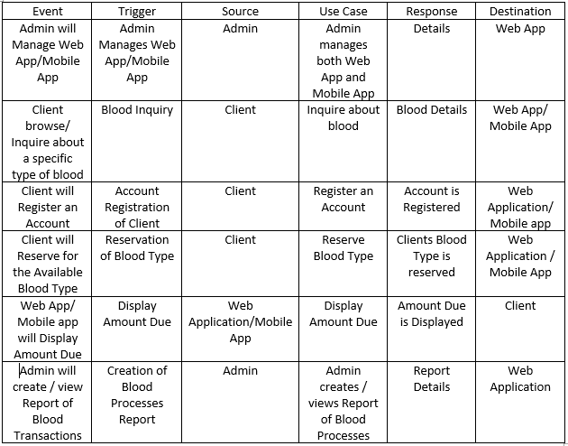

Use Case Diagram

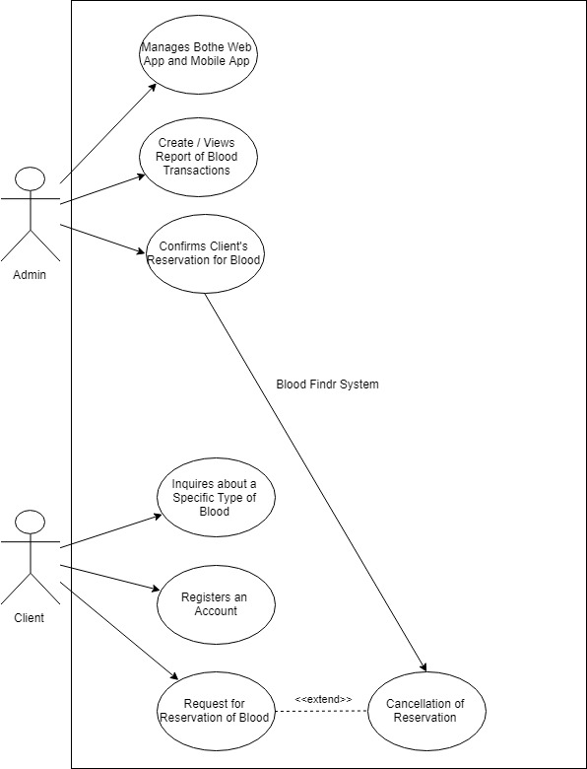

Use Case Full Description:

|  |  |  |
| --- | --- | --- |
| Use Case Name: | Manages both web app and mobile app | |
| Scenario: | Admin will manage both web app and mobile app | |
| Triggering Event: | Both mobile app and web app is managed by Admin | |
| Brief Description: | Admin will create, update, delete stored data in the system. All data (client, blood, branch, and system) will be managed by the admin. | |
| Actor: | Admin | |
| Related Use Case: | -Admin registers an account | |
| Stakeholders: | Web Application / Mobile Application | |
| Preconditions: | - Admin must have an account | |
| Post conditions: | Stored data will be kept confidential. | |
| Flow of Events: | Actor | System |
| 1. Admin logs in to the System. 2. Admin performs CRUD (create, read, update, delete) in the Database. | 2.1 System stores or removes data |
| Exception conditions: | Admin cannot alter client’s data | |

|  |  |  |
| --- | --- | --- |
| Use Case Name: | Confirms Client’s Reservations for Blood | |
| Scenario: | Admin will confirm Client’s reservation of blood | |
| Triggering Event: | Client’s reservation of blood is confirmed by Admin | |
| Brief Description: | Admin will confirm client’s reservation of blood and will notify the client that its desired blood type is reserved and ready for pick up. | |
| Actor: | Admin | |
| Related Use Case: | -Admin registers an account | |
| Stakeholders: | Clients, Web App / Mobile App | |
| Preconditions: | - Admin must have an account  - Stocks in Blood is known  - Client is verified through registration | |
| Post conditions: | Client will be notified of the confirmation. | |
| Flow of Events: | Actor | System |
| 1. Admin logs in to the System. 2. Admin double checks blood type availability. 3. Admin confirms Client’s reservation of blood. | * 1. System provides details of blood type and it availability.   2. System approves confirmation |
| Exception conditions: | Admin cannot confirm reservation if there are no stocks or all remaining stocks have already been reserved. | |

|  |  |  |
| --- | --- | --- |
| Use Case Name: | Checks Blood Type Availability | |
| Scenario: | Admin will check blood type availability in the Database | |
| Triggering Event: | Blood type availability is checked by the Admin | |
| Brief Description: | Admin will check whether the blood type is available and update the application’s database. | |
| Actor: | Admin | |
| Related Use Case: | Admin registers an Account | |
| Stakeholders: | Web App / Mobile App | |
| Preconditions: | - Admin must have an account  - Stocks in Blood is known | |
| Post conditions: | The Application will display current Blood Type Availability | |
| Flow of Events: | Actor | System |
| 1. Admin logs in to the System. 2. Admin double checks blood type availability in the system. 3. Admin updates the blood type availability in the application’s database, according with the branch’s stock. | 2.1 System provides availability of blood type.  3.1 System updates its blood type availability regarding the Admin’s input. |
| Exception conditions: | Admin can only check other branch’s blood type availability. Admin cannot update other branch’s blood type availability. | |

|  |  |  |
| --- | --- | --- |
| Use Case Name: | Creates / Views Report of Blood Processes | |
| Scenario: | Admin will create / view Report of blood processes | |
| Triggering Event: | Report of blood processes is created or viewed by the admin | |
| Brief Description: | Admin will create a report regarding blood transactions completed. | |
| Actor: | Admin | |
| Related Use Case: | -Admin registers an account | |
| Stakeholders: | Web Application | |
| Preconditions: | -Admin must have an account | |
| Post conditions: | Total number of transactions made about blood will be known. | |
| Flow of Events: | Actor | System |
| 1. Admin logs in to the system. 2. Admin views reports of blood transactions. 3. Admin creates reports of blood transaction | 2.1 System displays reports  3.1 System stores the report in the database |
| Exception conditions: | Reports can only be created and viewed using the Web Application. | |

|  |  |  |
| --- | --- | --- |
| Use Case Name: | Inquires about a specific type of blood | |
| Scenario: | Client will inquire about a specific type of blood. | |
| Triggering Event: | Blood type is inquired by client. | |
| Brief Description: | Client will inquire about a specific type of blood, whether if it’s available or not and where it’s available. | |
| Actor: | Client | |
| Related Use Case: |  | |
| Stakeholders: | Web App / Mobile App | |
| Preconditions: | -Client must have access to the application (no account needed) | |
| Post conditions: | The Application will display current Blood Type Availability of the inquiries of the client. | |
| Flow of Events: | Actor | System |
| 1. Client uses the web app / mobile app. 2. Client inquire about a specific type of blood. 3. Client can opt to reserve for that blood or not. | 2.1 System displays and provides information about blood. |
| Exception conditions: | Client must have an account to reserve for the blood. | |

|  |  |  |
| --- | --- | --- |
| Use Case Name: | Registers an Account | |
| Scenario: | Client will register an account | |
| Triggering Event: | Account is registered by client | |
| Brief Description: | An account is needed to avail of the service to request a reservation of blood. The client must register first an account. | |
| Actor: | Client | |
| Related Use Case: |  | |
| Stakeholders: | Web App / Mobile App | |
| Preconditions: | -Client must provide required information for the account registration | |
| Post conditions: | Client will have access to avail blood through the system. | |
| Flow of Events: | Actor | System |
| 1. Client fills up registration form and necessary information needed through the web app / mobile app. 2. Client is registered to the system | * 1. System stores client’s data in the database and approves registration |
| Exception conditions: | Client does not need to register if the client already has an account. | |

|  |  |  |
| --- | --- | --- |
| Use Case Name: | Request for Reservation of Blood | |
| Scenario: | Client will request for a reservation of blood. | |
| Triggering Event: | Reservation of blood is requested by client. | |
| Brief Description: | Client will request for a reservation of blood, so the admin can confirm and have the blood ready for the client to pick up. | |
| Actor: | Client | |
| Related Use Case: | -Client registers an account | |
| Stakeholders: | Admin, Web App / Mobile App | |
| Preconditions: | -Client must have access to the application  -Client must have an account | |
| Post conditions: | Through the application, a request for confirmation of blood from the client will be forwarded to the admin. | |
| Flow of Events: | Actor | System |
| 1. Client logs in to the System. 2. Client requests for the reservation of blood. 3. Client will receive confirmation. | 2.1 System will reserve blood.  3.1 System will confirm reservation through the admin. |
| Exception conditions: | Client must claim the blood at a given time, otherwise reservation of blood will be cancelled. | |

Object Diagram:

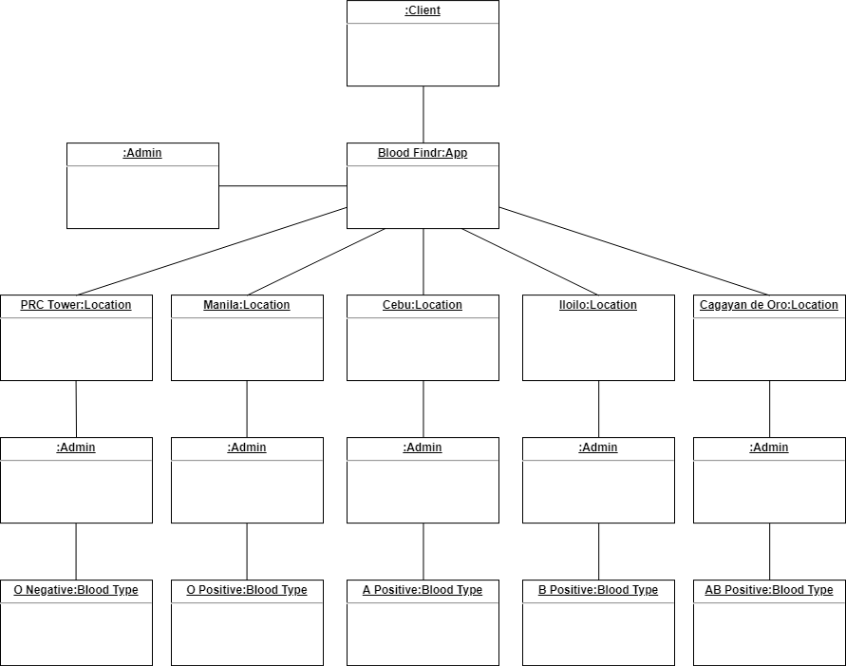

Data Flow Diagram:

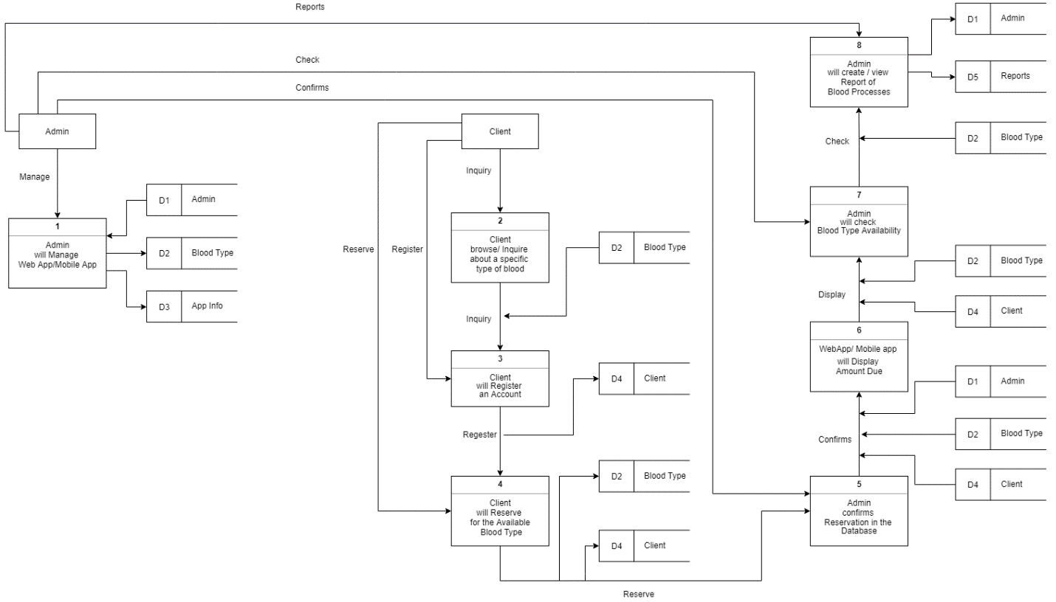

Context Flow Diagram:

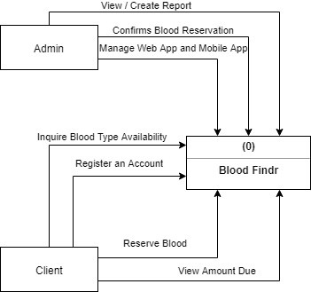

Activity Diagram: 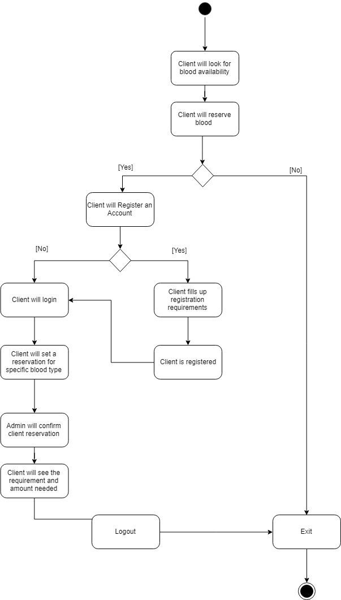

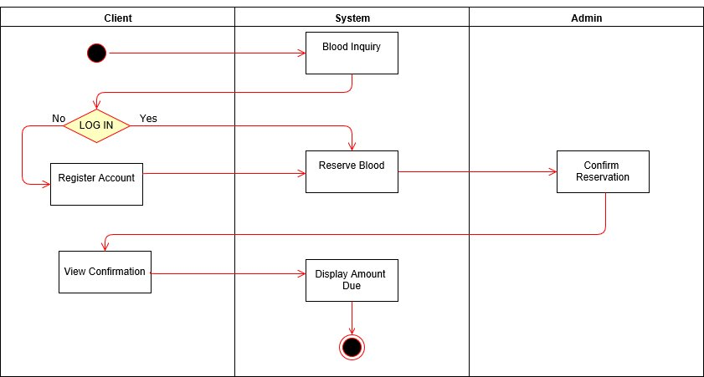

Class Diagram:

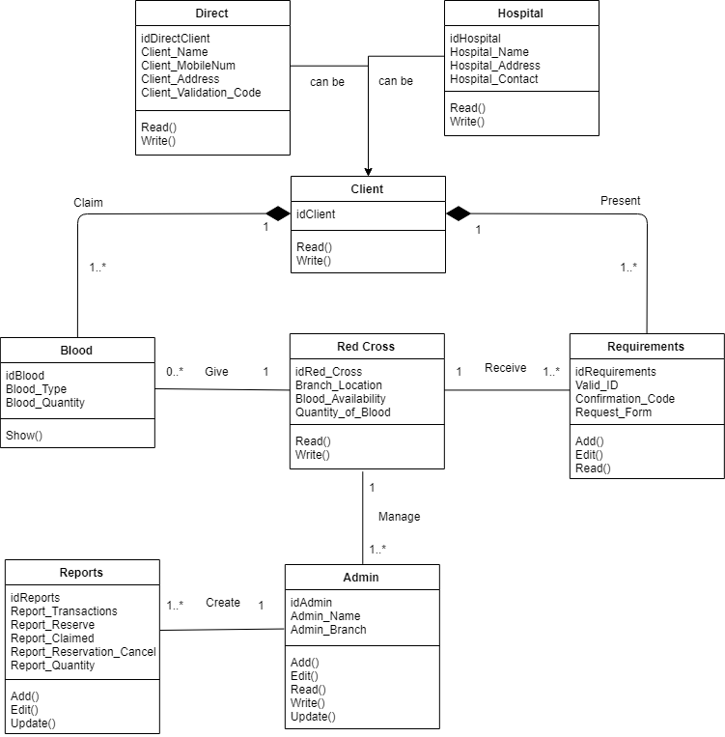

Entity Relationship Diagram:

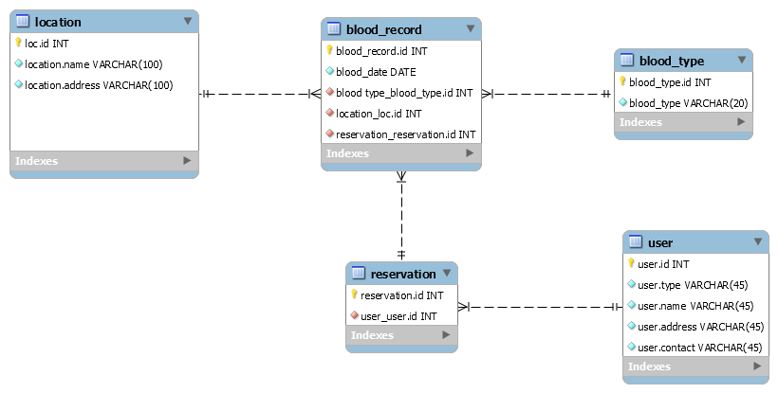

Data Dictionary:

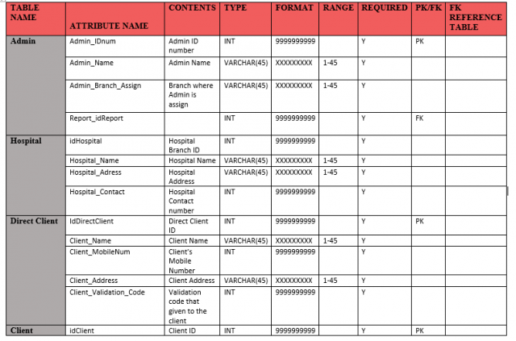

Sequence Diagram:

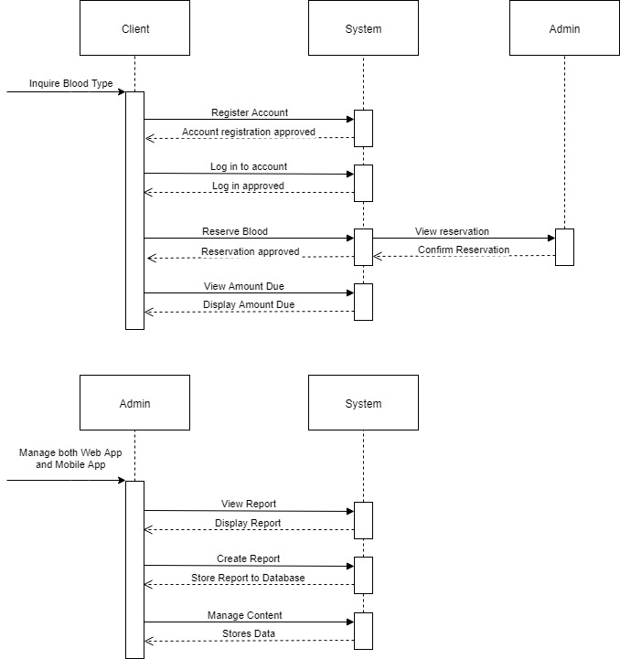

State Machine Diagram:

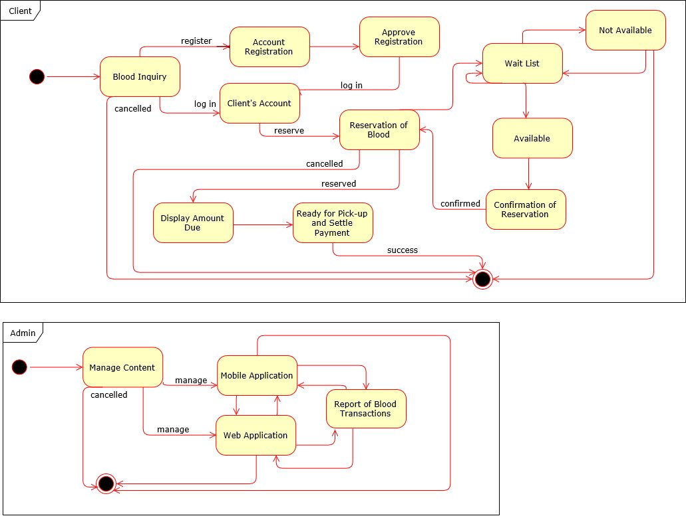

Timing Diagram:

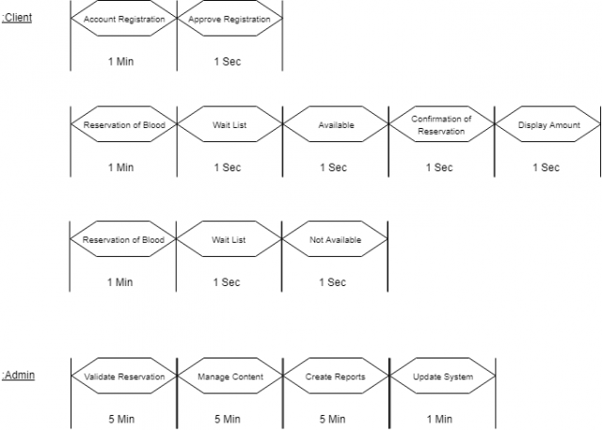

Communication Diagram:

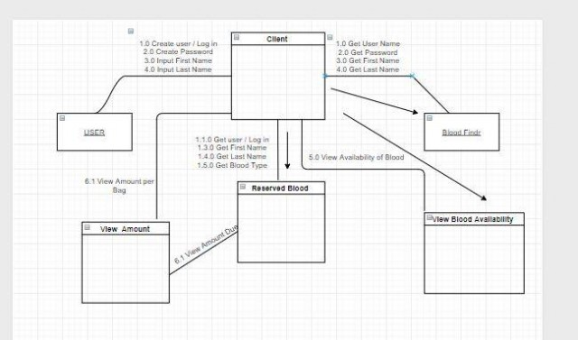

Component Diagram:

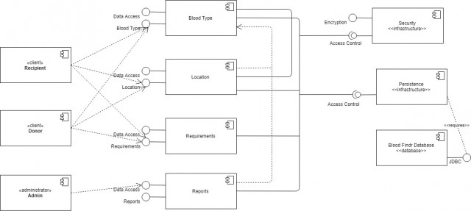

Deployment Diagram:

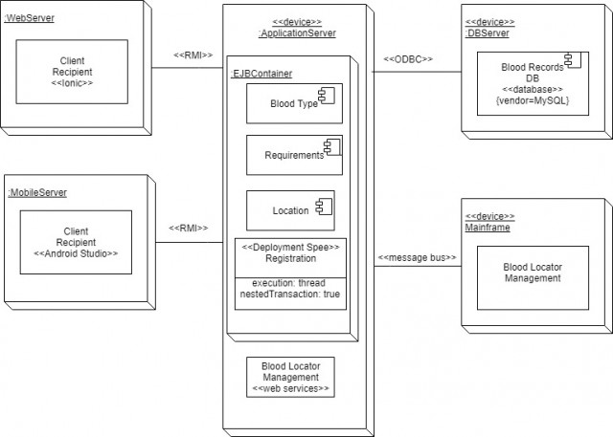

Package Diagram:

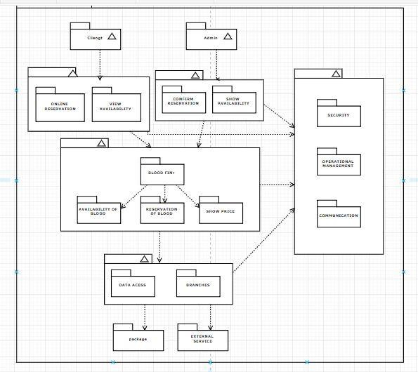

Use Case Package Diagram:

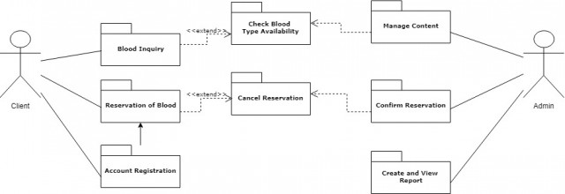

Composite Structure Diagram:

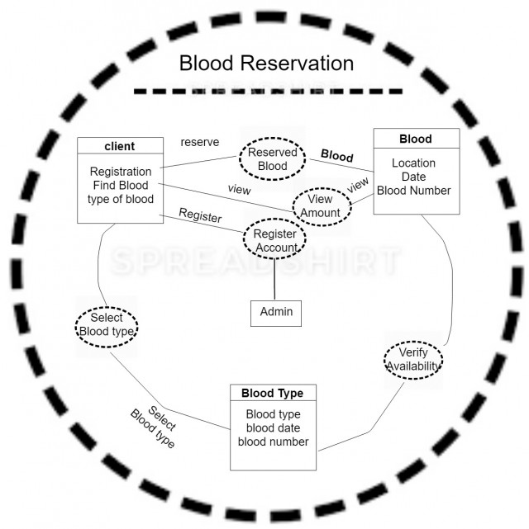

User Interface (Mobile):

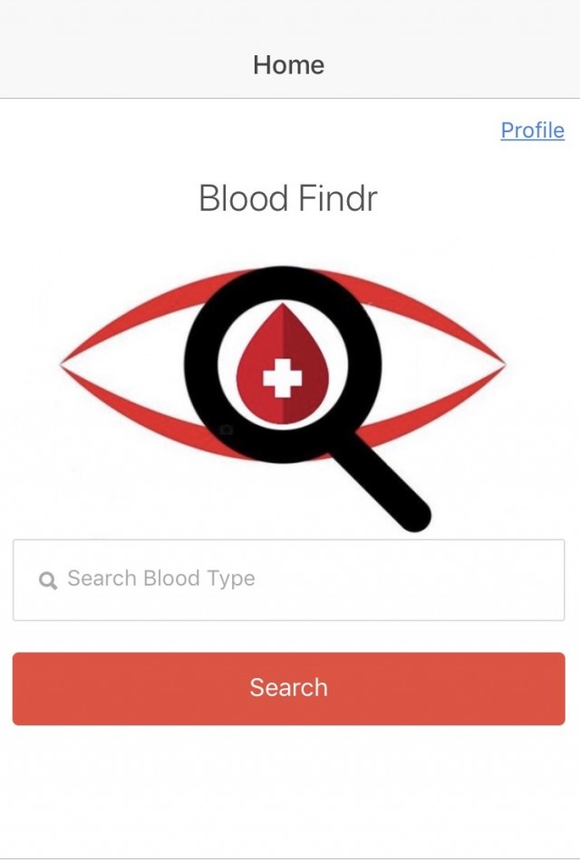

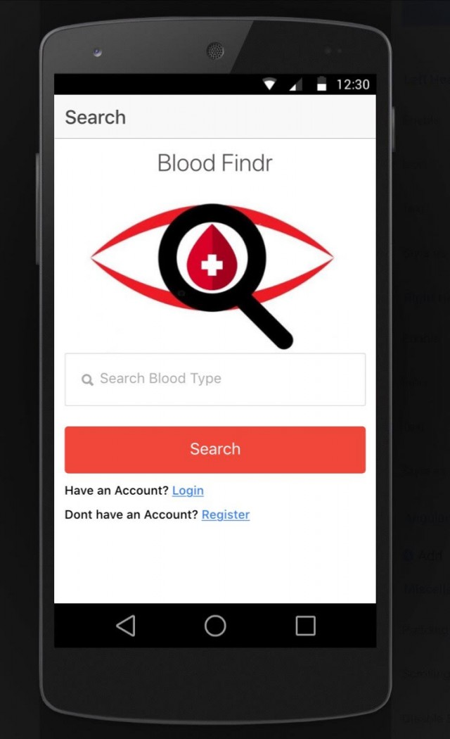

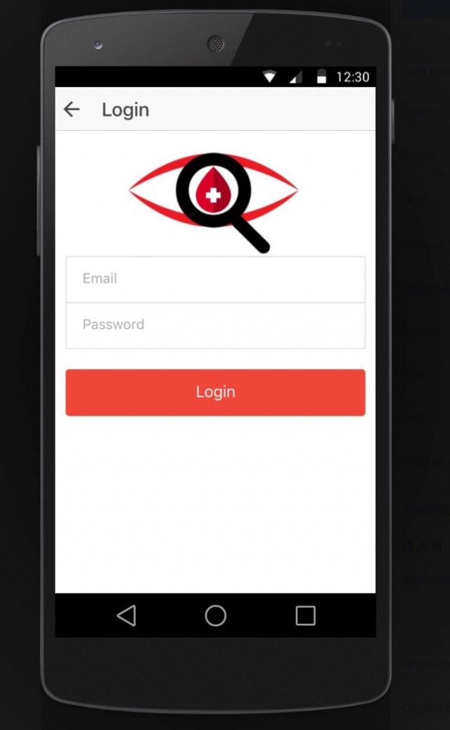

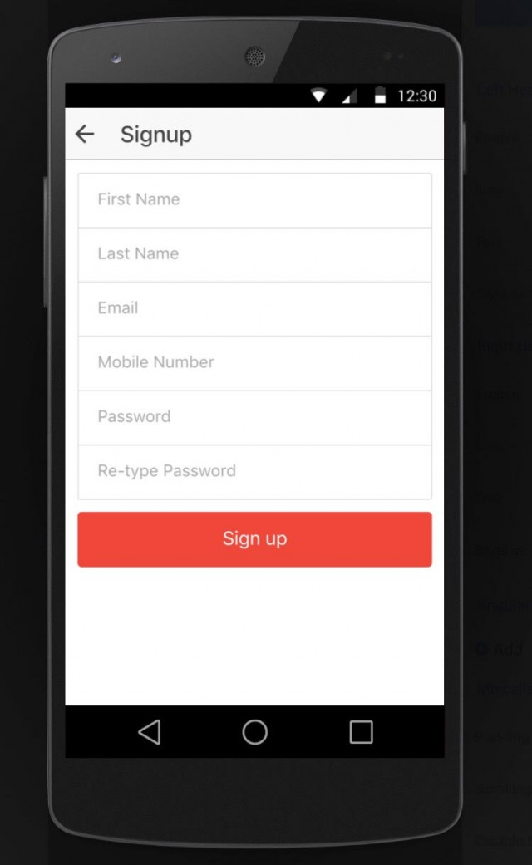

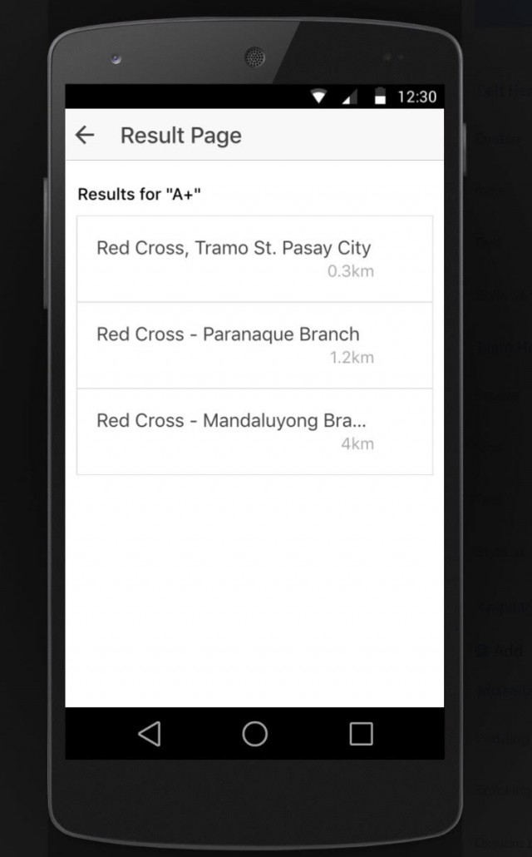

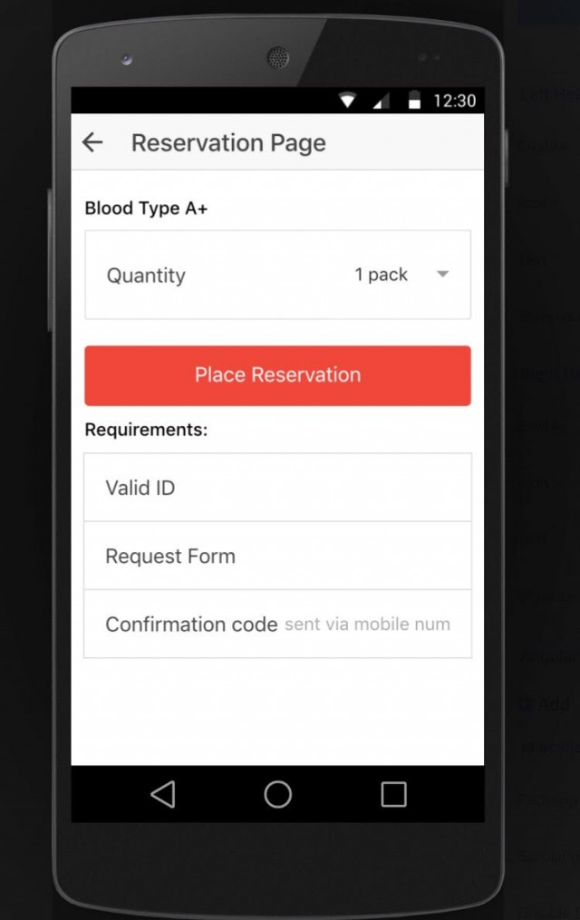

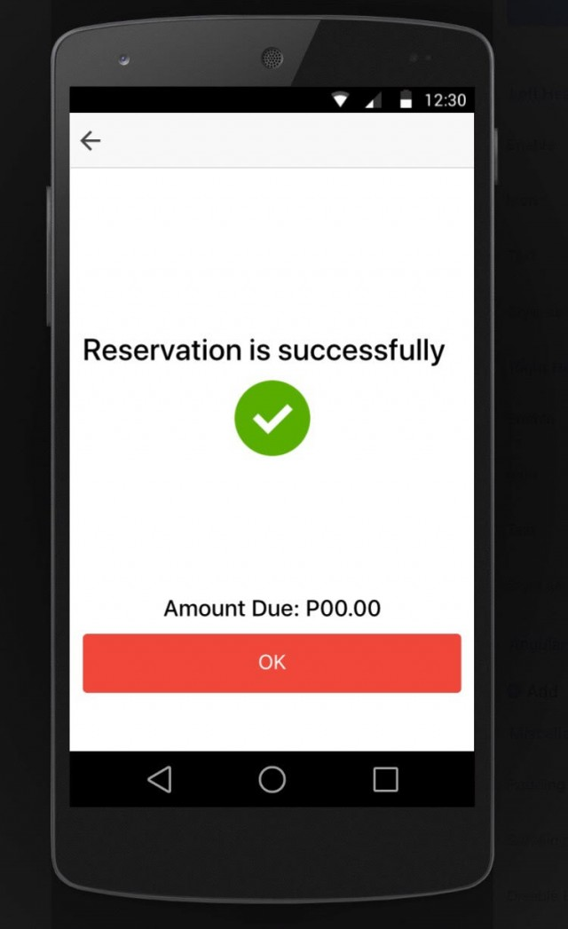

**Conclusions and Recommendation**

Red Cross has blood banks to administer clients in need of any blood-related operations such as blood transfusion, surgery, and similar cases. Availing of blood in the country takes a lengthy process of reservation through email or phone call. This kind of system is not actually efficient, considering the wide options we can utilize technology. The need for blood should be readily available, especially because it regards the life of a person. As an emergency situation, it requires immediate action. Though the process of blood availing in the country is technologically efficient, there will always be room for improvement. As students of BS-IT, we have proposed an easier, user-friendly, and more efficient way of catering clients in need of blood. Blood Findr, is a web-based and mobile-based application that administers clients in need of blood for hospital operations. The application requires the user's name and phone number as vital information whether blood recipients or blood-related clients. The app will then provide a list of Red Cross blood facilities with the available blood type, as well as prompt blood donor to report to the hospital with the client in need of blood. Simple as that, we make the process of blood availing easier as it caters to more clients and hospitals. The improved system also promotes the more updated type of application that makes transactions and processes easier, through verification codes, admins can easily verify and categorize their clients and secure the data. Therefore, we consider it feasible that our system be implemented to our target client, providing an easier and more efficient availing of blood. This can replace their traditional process and create a larger network of clients as well as a more updated, more efficient application.